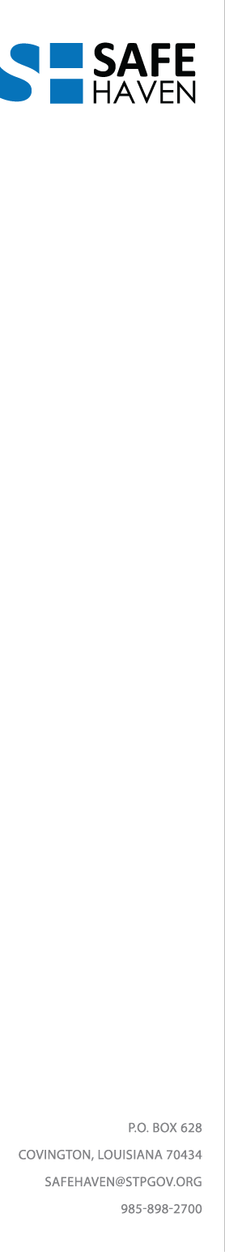

Safe Haven Advisory Board meeting

Monday, June 12, 2017, 11:00AM

1. Meeting called to order, Jan Robert
2. Roll call, quorum established, Adele
3. Approval of minutes, March 2017
4. Safe Haven update and overview, March-May 2017, Jan Robert
5. Facility plan update
6. RFI/RFQ
7. Safe Haven Committee reports
8. Jail Diversion, Judge Peter Garcia
9. Healthcare, Dr. Charles Preston and Richard Kramer
10. Training and Education, Major Wharton Muller, Nick Richard
11. Other business: Grants
12. Meeting adjourned

Safe Haven Quarterly meetings, 2017

September 11, 11AM

December 11, 11AM

Please go to the STP Safe Haven website [www.safehavenstp.org](http://www.safehaven.stp.org) to sign up for meeting notifications and announcements.